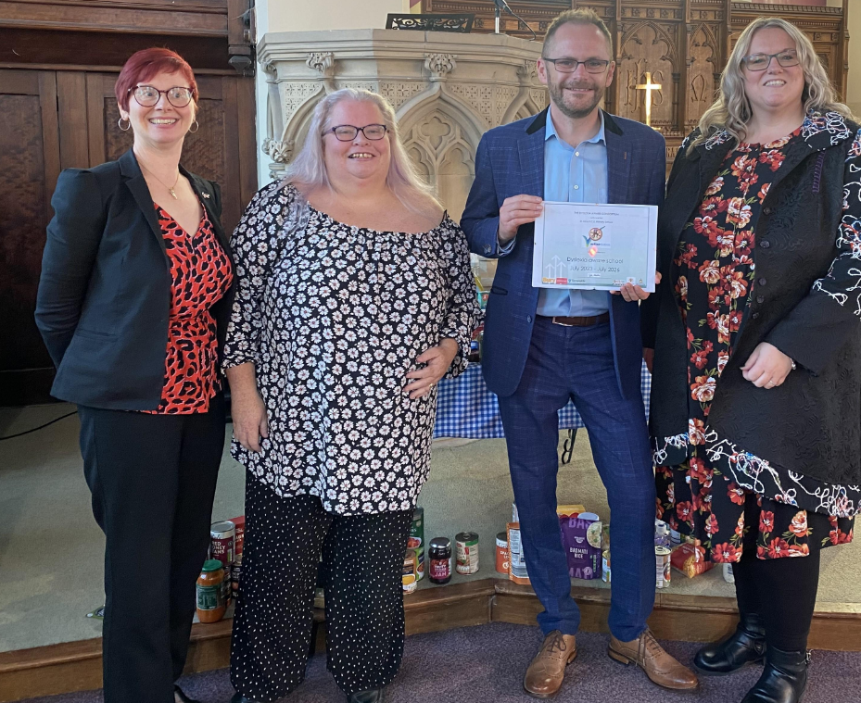

We were awarded the Dyslexia Awareness Quality Mark in 2023 which promotes inclusion and diversity.

