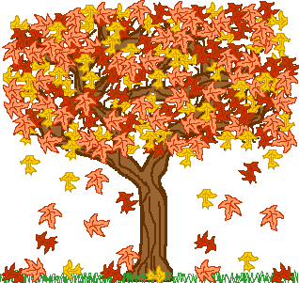

# Class 4 Newsletter

# Autumn Term 2023

Mrs Jolley & Mrs Falshaw

*‘Believe and Achieve Together’*

Welcome Back! We hope that all of the children and parents had a super Summer break and are ready for some cosy Autumn days and nights! Here comes Autumn then and we certainly have a great term ahead with lots of activities, events and learning. We will have a new exciting topic focus and of course we have our High Adventure trip, which is super exciting! There will be so much to keep us all busy!

History – To be or not to be a Tudor?!

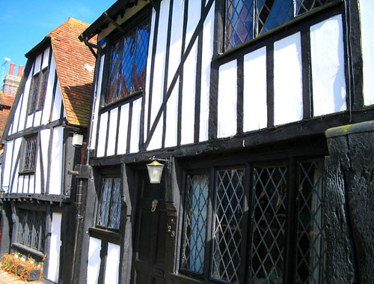

The Tudors were a family of five rulers and 118 years that changed the lives of English people. We will question who these Kings and Queens were and the legacy they left behind.

Geography – Trading Nations.



Trading today and through different periods of History. We will explain the UK’s trade links with other countries including Europe and America.

***Dates for your diary***

Welcome Walk – 29th Sept

Open Afternoon – 2nd Oct (1.30-3pm)

Harvest – 12th Oct

High Adventure 9-11th Oct

Parent/Teacher Meetings - 16th & 18th Oct

Half-Term-20th Oct

Individual Photos -27th Nov

Open Evening – 15th Nov (6-7.30pm)

End of Term Service -21st Dec

RE: We will look at how and why Christians use the Bible, People of Faith and Christmas around the World

Art and Design Technology: Drawing Tudor portraits, making Tudor houses, sewing techniques and Macbeth scene art.

PE: This Term PE will take place on Monday and Wednesday.

Music: Tudor Music and instruments, recorders will be played, as well as learning a Tudor song. Macbeth from BBC Music will start us off!

MFL: Talking about us, school subjects and opinions plus City life.

ICT: Word processing using Google Docs, research and online safety.

# Thank you to all our parents for your continued support. As always, if you have any questions or concerns do not hesitate to come and see us. Mrs Falshaw and Mrs Jolley!

**Maths:**

The children will access a daily lesson including a mixture of number work, including place value to 10 million and the use of 4 operations on whole numbers, as well as fractions and decimals, position and direction. Maths teaching will also include a focus on arithmetic strategies and the developing of reasoning skills across the maths curriculum. Multiplication tables are visited weekly, including the rehearsal of common multiples, factors and prime numbers.

**Science:**

Science teaching this term will focus on Evolution and Inheritance, exploring both Charles Darwin and Alfred Wallace theories. Scientific evidence will be explored from plants and animals to support these theories. After half-term we look at Light - how we see, shadows, reflection and refraction. We will learn about Isaac Newton’s theory.

**Literacy:** As readers, we will be focussing on reading comprehension skills such as skimming and scanning, identifying main ideas and predicting events using our Hagstone story. We will follow the NC for spelling, looking at spelling rules, ways to remember spellings and learn spelling lists every week. We will use spellingframe.com to help in this. Handwriting will be taught weekly. As writers, we will be developing our fiction and non-fiction through a variety of genre. We will look at the power of imagery in poetry through the eyes of Alfred Noyes’ poem ‘The Highwayman’. The children will be looking at persuasive ways to write and develop our use of powerful adjectives and super sentence openings. We will learn about auto/biographies in order to write about famous Tudors. Additionally, we will explore the world of Shakespeare, studying Macbeth, where we will involve dramatic convention.

Children will be offered opportunities to present their work verbally in a variety of ways including drama, presentations (including the use of ICT) and daily speaking activities