Believe and Achieve Together

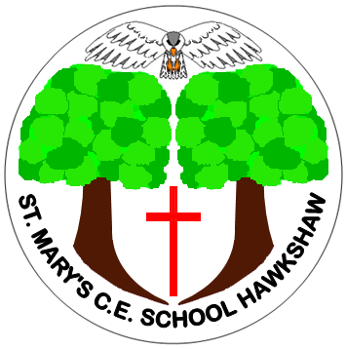

St Mary’s CE Primary School
Music Policy
Adopted: June 2023
Reviewed: January 2026
Next Review: January 2028

Purpose of Study
- Music is a powerful, unique form of communication that can change the way pupils feel, think and act. It transcends different cultures, abilities and generations.
- Listening to and making music fulfils an instinctive human need for self -expression and creativity. It stimulates responses both on emotional and intellectual levels.
- Music can be a lifelong source of pleasure. It is education for life.

Aims
To encourage, all pupils to:
- develop musical skills and concepts through listening, appraising, performing and composing.
- develop social skills through co-operation with others in the shared experience of music making.
- develop an understanding of musical traditions and developments in a variety of cultures and religions
- be motivated to enjoy and succeed in music
- participate in hymns and reflection/reflective music during collective worship
- Music contributes to the wider aims of Primary Education including, literacy, ICT, P.E, Art, P.S.H.E. and citizenship.
- Music can develop skills, attitudes and attributes that can support learning in other subject areas that are needed for life and work skills – e.g. listening skills, concentration, creativity, intuition, aesthetic sensitivity, perseverance, self confidence and sensitivity towards others.

In Music opportunities will be created for pupils to:
- listen, appraise, perform and compose in a variety of genres, styles and audiences.
- undertake a balanced programme of activities
- work individually, in groups or as a whole class
- make appropriate use of I.C.T. to create and record music
- make use of outside agencies, peripatetic teachers, music concerts etc .
- make use of audio/visual material
- record findings in a variety of ways
- to learn one musical instrument in whole class ensemble lessons.
- to participate in small group or individual musical tuition on chosen instrument using peripatetic music teachers.
- to perform to wider audiences including parents and the local community .

Planning, Assessment and Reporting
Planning is provided by ‘Get Set 4 Music’ which is a comprehensive primary school music curriculum and scheme of work created by ‘Get Set 4’ Education, that aligns with national curriculum and Ofsted requirements.

Music Progression of Skills



